What is Squash

1.Squash in git means to combine multiple commits into one.

2. You can do this at any time by using git Interactive Rebase.

3.Please note that there no such thing as a Stand-alone git Squash command.

4.Using squash we can merge existing multiple commits into a single one.

5.Suppose you worked on separate branch and produced a number of commits in the context.

6.It might even be quite a high number of commits.

7.You want to merge your work back to the main branch in this you decide to squash or not

8.then you will squash multiple commits into single commit

Git rebase -i HEAD~(N)

Git rebase -i is a interactive tool which squash commits

Will we will squash N number commits

For example

I have 4 commits. I want squash last 3 commits into one

Git rebase -i HEAD~3

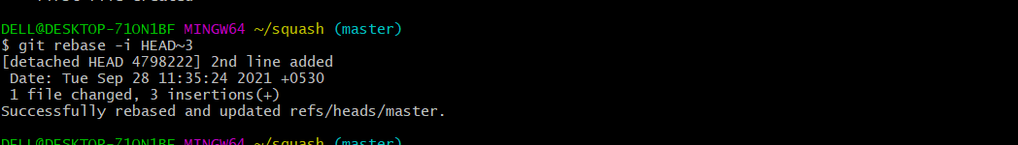

After that it will open a editor

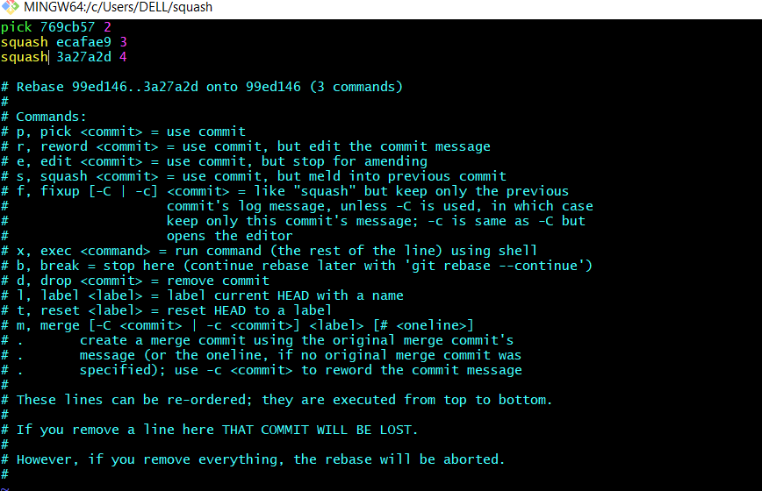

We marked last two commits to squash

The squashed commits will be merged to the main commit the commit marked as the pick

After saving the this. It will open the editor again and provide commit message and save it

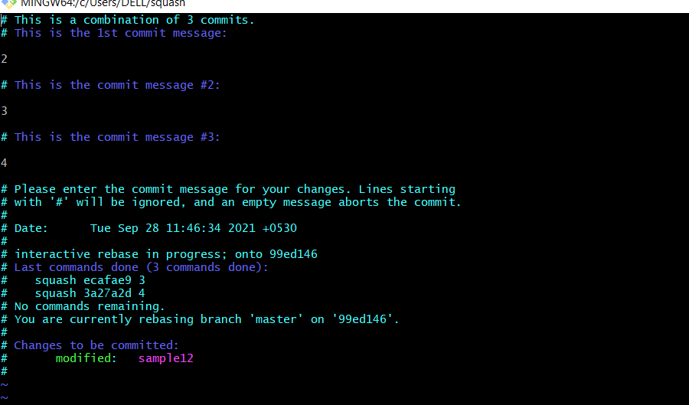

after that check the logs commits will be squashed or not

after that check the logs commits will be squashed or not

